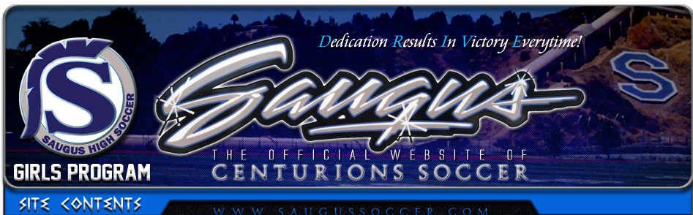CONGRATULATIONS
& WELCOME TO THE 2021/22 SOCCER TEAM!
Now what?
- Parents, please print out and sign all of the REQUIRED documents from the soccer website (saugussoccer.com) and be sure to choose the correct team that your daughter is on.
- Players will be fitted for uniforms as we get closer to the season.
- There is a MANDITORY Parent/Player Meeting on Wednesday (varsity only), September 8th at 6:30pm via Zoom (link is posted on the website on the calendar of events page). JV and Frosh Parent/Player meeting will be onThursday September 9th at 7:30pm (link is posted on the website on the calendar of events page).
- Make sure to check the new and updated website (saugussoccer.com) and follow us on Facebook for updates, events, Q&A, and reminders!!! https://www.facebook.com/SHSGirlsSoccer/
You can also follow us on Twitter at @saugus_soccer and Instagram @saugusgirlssoccer
- Parents, begin thinking about how you can help support the girls this season. We will discuss all the areas where your help will be needed at the Parent Meetings on 9/8&9.

